CALL FOR PAPERS
Special Session on “Please add here the Title of the special session...............................”
2023 5th International Conference on Big-data Service and Intelligent Computation
October 20-22, 2023, NTU@one-north Executive Centre (ONEC), Singapore
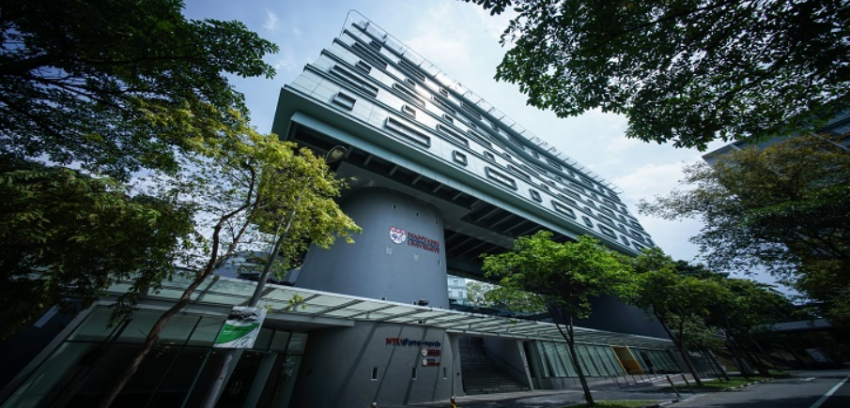
ORGANIZED AND CHAIRED by
Organizer 1 name and affiliation
Email address
Organizer 2 name and affiliation
Email address

SPECIAL SESSION DESCRIPTION (no more than 150 words)

Please add a short description of the topic

TOPICS COVERED (no more than 5)
- Topic 1
- Topic 2
- Topic 3
- Topic 4
- Topic 5

Schedule:
Deadline for submission of the paper (s) to the Zmeeting system submission site by selecting the desired special session- June 25, 2023 ( or next round-July 25, 2023)
Notification of acceptance – July 25, 2023(or next round-August 25,2023)

Supported by
Technical Supported by

Indexed by:

Contact Method:
Conference Secretary: Ms. Ellie Zheng
bdsic@acm-sg.org

